This is a sample of the resources Legato Strategic Consulting provides through dedicated support to institutions like yours.

How to Update Submit Course Section EIB Default Template

Use this guide to avoid Submit Course Section EIB failure by keeping templates up-to-date with appropriate defaults.

In this guide, you will learn:
- Basic introduction to the EIB and EIB Template
- Fields to update on Submit Course Section default template
Note: Screenshots for this guide are taken from the Submit Course Section EIB.

ABOUT ENTERPRISE INTERFACE BUILDER (EIB) TEMPLATES

An EIB (Enterprise Interface Builder) is a tool in Workday that helps you move data in or out of the system, like a smart import/export feature. You can use it to upload or download large sets of data without doing it all by hand, which saves time and reduces errors.
An EIB template is a pre-made spreadsheet or file format that lays out what data Workday expects (like column names and structure). You use it to make sure you're sending the right info into Workday in the right way.

CHALLENGE
EIB templates can become outdated if the system changes (for example, if fields are added or renamed). Before importing data, always double-check you are using the most up-to-date version. The more time since the EIB template’s last update, the more likely it will fail.
Time Since Last Update | Likelihood of EIB Failure | Notes
0-6 Months | Low | Generally stable unless BP or security changed.
6-12 Months | Moderate | One major Workday release could have introduced breaking changes.
12+ Months | High | Multiple releases may have deprecated fields or changed behaviors.

UPDATE THE DEFAULTS IN THE TEMPLATE
- To locate the EIB Template, go to View Integration System
- Enter “INTSYS: [EIB name]”
- Locate and view the report with all your integration systems. Note: This should contain the date of last update to help determine whether a new update is needed)
- Click “Related Actions”
- Click “Template Model”
- Click “View”

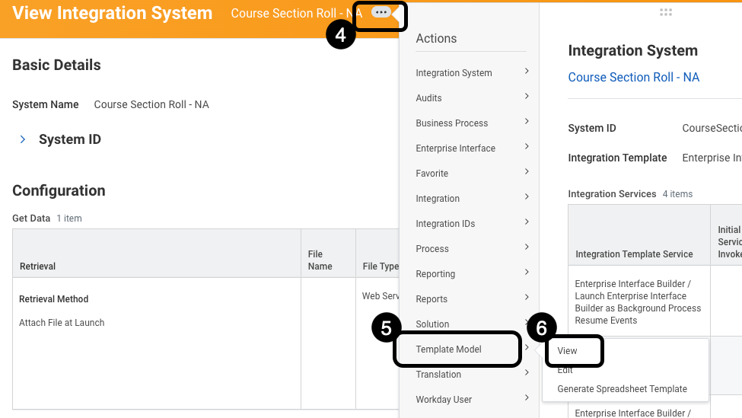

- Click “Edit Template Model Sheet”. A series of rows and columns will display the current defaults
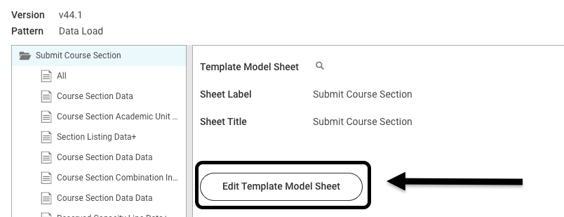

- Review and update the following fields.

Template Model Area Label: Course Section Academic Unit Data+
Label | Course Section Academic Unit Data
Column “Label” | Academic Unit
Change Reference ID column from: |  | Academic Unit Hierarchy
Change Reference ID column to: |  | Academic Unit ID
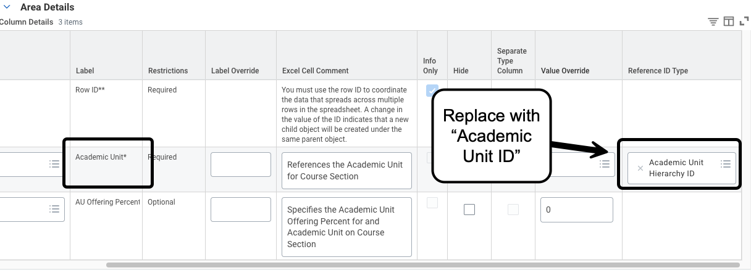

Template Model Area Label: Reserved Capacity Line Data+
Label | Reserved Capacity Line Data
Column “Label” | Reserved Capacity Line Eligibility Rule
Change Reference ID column from: |  | Application Additional Education Interest Eligibility Rule ID
Change Reference ID column to: |  | Eligibility_Rule_ID
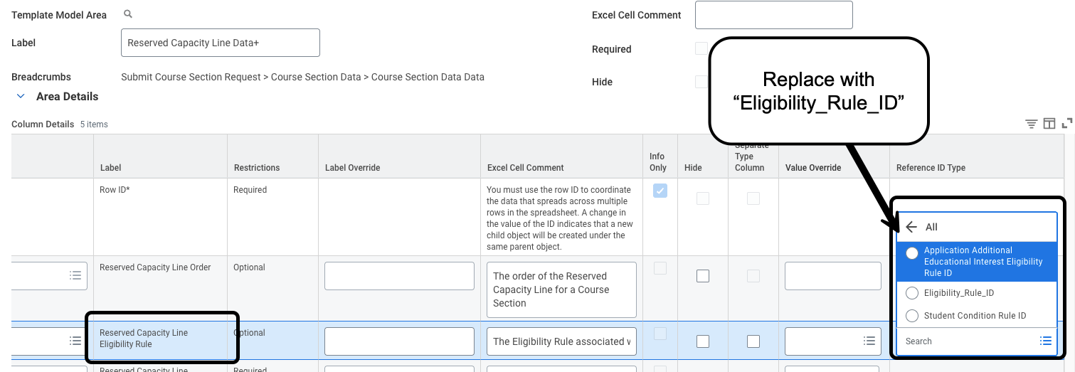

Template Model Area Label: Instructor Role Assignment Data +
Label | Instructor Role Assignment Data +
Column “Label” | Assignees to Add+ / Assignees to Remove+
If you want to change instructors, change Reference ID column from: |  | Academic Affiliate ID
Change Reference ID column to: |  | Employee ID
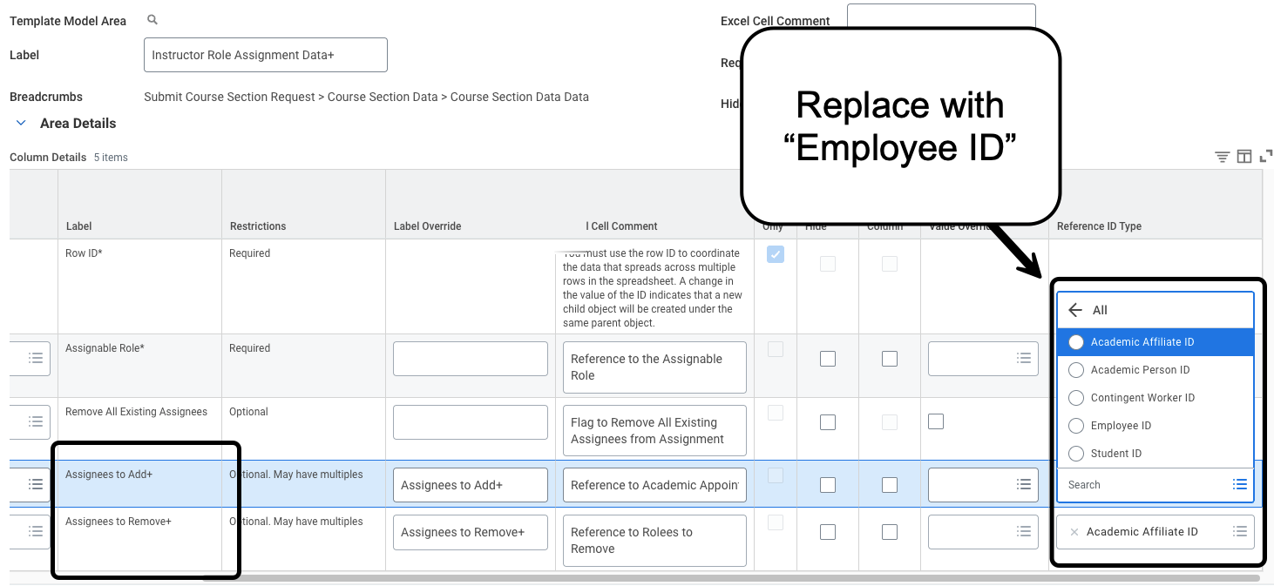
Template Model Area Label: Course Section Data Data
Label | Course Section Data Data
Column “Label” | Student Eligibility Rule
Change Reference ID column from: |  | Application Additional Education Interest Eligibility Rule ID
Change Reference ID column to: |  | Eligibility_Rule_ID
